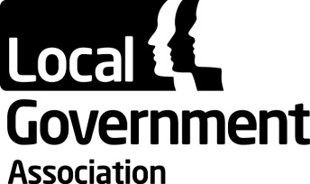 | LGA General Assembly  5 July 2016
LGA consolidated financial statements for the year to 31 March 2016
Purpose of the Report

To invite the General Assembly to receive the LGA consolidated financial statements for 2015/16.

Summary

The LGA’s consolidated financial statements for the year ended 31 March 2016 are included in the LGA Annual Report, enclosed with this agenda. These are the first LGA accounts to be prepared using the new Financial Reporting Standard – FRS102. They were reviewed by the Audit Committee on 6 June and approved by the LGA Leadership Board on 8 June. They have received an unqualified audit opinion from the external auditors PKF Littlejohn LLP. The auditors will sign the consolidated accounts once all of the financial statements and letters of representation for the individual companies feeding into the consolidated accounts have been signed following their board meetings in June 2016.

The consolidated financial statements show an operating surplus of £3.160 million. The main causes of the surplus being £0.7 million net savings from restructuring of corporate and ICT services and £0.850 million additional external income contributions to overheads. These savings were increased by the net impact of FRS102 Accounting adjustments arising from the £3.523 million unrealised gain on investment properties offset by an additional £1.815 million current cost pensions charge.

The overall pension deficit decreased by £18.109 million to £94.751 million. This valuation has been carried out in line with FRS102 accounting standards and is therefore subject to market performance on a specific date. The LGA is making additional pension contributions in order to eliminate the deficit over a period of between 15 and 22 years.

Recommendation

That the General Assembly receives the financial statements for the year to 31 March 2016.

Contact officer: | Paul Brack
Position: | Strategic Finance Manager
Phone no: | 0207 187 7309
E-mail: | Paul.brack@local.gov.uk

